COURSE ASSIGNMENT REPORT
ITA0606 – Machine Learning
Design and Development of an Intelligent Real-Time Traffic Congestion Prediction System Using Machine Learning
Item | Details
Department | ECE
Programme | B. Tech ECE
Course Code & Course Name | ITA0606– Machine Learning
Academic Year / Batch | 2024-2028
Faculty Name | Dr K Baskar
Student Name & Register Number | Balakumaran M (192412179), Thyaneshwaran K(192412187),Pravin A(192412121)
Assignment Title | Design and Development of an Intelligent Real-Time Traffic Congestion Prediction System Using Machine Learning
Date of Issue
Date of Submission
Maximum Marks | 100

A. Assignment Information
Item | Details
Course Outcomes (CO) | CO6: Applies Decision Tree Learning for representing and classifying traffic-congestion concepts.  CO7: Uses NumPy and Pandas for data preprocessing, statistical analysis, aggregation, and visualization.  CO8: Integration and application of theoretical and practical ML knowledge.
Bloom's Taxonomy Level | Apply (L3) + Analyze (L4)
SDG Mapping | SDG 11 – Sustainable Cities and Communities  SDG 9 – Industry, Innovation and Infrastructure
Industry / Societal Relevance | Traffic congestion prediction can support better route management, adaptive signal timing, reduced travel delays and more efficient use of urban transportation infrastructure.

B. Assignment Problem / Challenge
Urban traffic conditions change continuously with vehicle demand, road occupancy, time of day, weather and other operating conditions. Traffic authorities need a practical way to turn these measurements into an understandable congestion level before queues become difficult to manage. Manual observation is not suitable for large road networks, while raw sensor values do not directly provide an actionable traffic category. This assignment develops a machine-learning workflow that preprocesses traffic observations using NumPy and Pandas, analyses traffic patterns, and uses a Decision Tree classifier to predict Low, Medium or High congestion.

C. Problem Statement
A smart-city traffic management system receives near-real-time measurements from road sensors and camera-based monitoring systems. The available information includes vehicle count, average vehicle speed, time of day, day of the week, weather condition and road occupancy. The objective is to use these variables to predict the current congestion state so that traffic authorities can take suitable management measures.
The proposed solution addresses the following tasks:
1. Collect and preprocess the traffic data using NumPy and Pandas.
2. Perform statistical analysis and visualization to identify patterns between traffic conditions and input parameters.
3. Develop a Decision Tree classification model to predict the current traffic congestion level.
4. Identify the important traffic parameters influencing the prediction.
5. Test the model using new traffic data and predict the congestion level.
6. Evaluate the model using accuracy, precision, recall, F1-score and a confusion matrix.
7. Discuss how the prediction can help with route management, signal timing and congestion reduction.

D. Requirements and Constraints
Category | Applicable Requirement / Constraint
Functional | Traffic data with vehicle count, speed, time, day, weather and road occupancy; preprocessing; statistical analysis; at least five visualizations; Decision Tree classification; feature importance; unseen-data prediction and evaluation.
Performance | The model should provide dependable classification of Low, Medium and High traffic states and should be assessed using multiple evaluation metrics.
Technical | Python implementation using NumPy, Pandas, Matplotlib and scikit-learn, including categorical encoding and train-test partitioning.
Data Quality | Duplicate, missing and inconsistent records should be checked before model training, and categorical values should be represented numerically.
Interpretability | The prediction process and important traffic parameters should be understandable to traffic-management personnel.
Scalability | The workflow should be extendable from historical traffic data to continuous streams from several monitored road segments.
Ethical / Privacy | Camera-based information should be limited to what is necessary for congestion estimation and should avoid unnecessary retention of personal information.
Sustainability | Better traffic flow can reduce unnecessary idling and travel delay, supporting more efficient urban transportation.

E. Student Work

1. Problem Understanding and Formulation

What is the problem?
The problem is to classify the current state of an urban road as Low, Medium or High congestion from measurable traffic conditions. The system combines direct road measurements such as vehicle count, speed and occupancy with contextual variables such as time, day and weather. The overall workflow is designed so that the same preprocessing and prediction steps can later be applied to live traffic measurements.

Expected outcomes
· A clean traffic dataset containing the required input variables and congestion labels.
· A reproducible preprocessing procedure using NumPy and Pandas.
· Statistical summaries and at least five useful traffic visualizations.
· An interpretable Decision Tree classifier for three congestion classes.
· A feature-importance analysis showing which traffic variables contribute most to the prediction.
· A prediction for a new traffic observation that was not used during training.
· Evaluation using accuracy, precision, recall, F1-score and a confusion matrix.
· A discussion connecting the prediction to practical traffic-management decisions.

Available information / data
A reproducible demonstration dataset of 1,200 traffic observations was prepared. Each record contains vehicle count, average speed, hour, day, weather, road occupancy and a congestion label. The dataset was generated with a fixed random seed so that the analysis can be repeated. Vehicle count, occupancy and speed form the main road-state variables, while time and weather provide additional context.
Attribute | Type | Description
Vehicle_Count | Numerical | Approximate number of vehicles detected on the monitored road segment.
Average_Speed_kmph | Numerical | Average vehicle speed in kilometres per hour.
Hour | Numerical | Hour at which the traffic observation was recorded.
Day | Categorical | Day of the week.
Weather | Categorical | Observed weather condition.
Road_Occupancy_pct | Numerical | Estimated percentage of road capacity occupied.
Congestion_Level | Target | Low, Medium or High congestion.

Assumptions
· The traffic records represent a defined road segment and are collected at reasonably regular intervals.
· Vehicle count, speed and occupancy provide useful indicators of current traffic conditions.
· Day and weather can be encoded without removing useful information.
· The demonstration dataset is synthetic and is intended to show the method rather than represent a specific city's traffic network.
· The Decision Tree is selected because it provides a simple and interpretable classification approach.

Constraints to be satisfied
· The model must classify all three congestion states.
· The test set must remain separate from the training data.
· The same feature-processing procedure must be used for training and new-data prediction.
· The evaluation must include accuracy, precision, recall, F1-score and a confusion matrix.
· The final discussion must address practical use, limitations, privacy and sustainability.

2. Application of Course Knowledge
The assignment applies Decision Tree learning, data preprocessing, statistical analysis, aggregation, visualization and model evaluation. NumPy is used for numerical processing, Pandas for structured data handling, Matplotlib for visualization and scikit-learn for the Decision Tree and evaluation metrics.

2.1 Data Collection and Preprocessing
The dataset was first inspected for dimensions, data types, duplicate records and missing values. Duplicate rows were removed and incomplete records were excluded before model training. Numerical variables were retained as numerical features. The categorical Day and Weather fields were converted into binary indicator columns using one-hot encoding. The Congestion_Level field was separated as the target variable. Finally, the data were divided into 80% training and 20% testing sets using stratification so that all three congestion classes remained represented.
Table: Dataset Overview
Item | Details
Total observations | 1,200
Input attributes | 6: vehicle count, speed, hour, day, weather, occupancy
Target attribute | Congestion_Level
Target classes | Low, Medium, High
Training / testing split | 960 / 240 observations (80% / 20%)
Class distribution | Low: 282; Medium: 693; High: 225
Categorical preprocessing | Day and Weather converted using one-hot encoding
Preprocessing Step | Purpose
Duplicate check | Prevents repeated observations from influencing the model.
Missing-value check | Avoids invalid or incomplete model inputs.
Categorical encoding | Converts Day and Weather into numerical features.
Target separation | Keeps Congestion_Level separate from the input variables.
Stratified train-test split | Maintains the class distribution in training and testing data.

2.2 Statistical Analysis and Visualization
The exploratory analysis was used to understand the traffic dataset before classification. The congestion-class distribution shows the number of observations in each state. Vehicle count was compared with average speed to observe their relationship. Hourly aggregation was used to identify periods with increased vehicle demand. Road occupancy was compared across congestion classes, and weather-wise occupancy averages were examined.
Table: Statistical Analysis and Observed Relationships
Analysis | Variables / Grouping | Observed use in the study
Class distribution | Congestion_Level | Shows the relative number of Low, Medium and High observations.
Vehicle–speed relationship | Vehicle_Count vs Average_Speed_kmph | Used to examine how increasing traffic demand relates to average speed.
Hourly aggregation | Hour and Vehicle_Count | Used to identify periods with increased vehicle demand.
Occupancy by class | Road_Occupancy_pct and Congestion_Level | Shows how road usage changes across Low, Medium and High states.
Weather-wise occupancy | Weather and Road_Occupancy_pct | Used to examine differences in road occupancy under weather conditions.
Correlation / relationship check | Numerical traffic variables | Relationships were inspected before model training rather than treating the classifier as a black box.
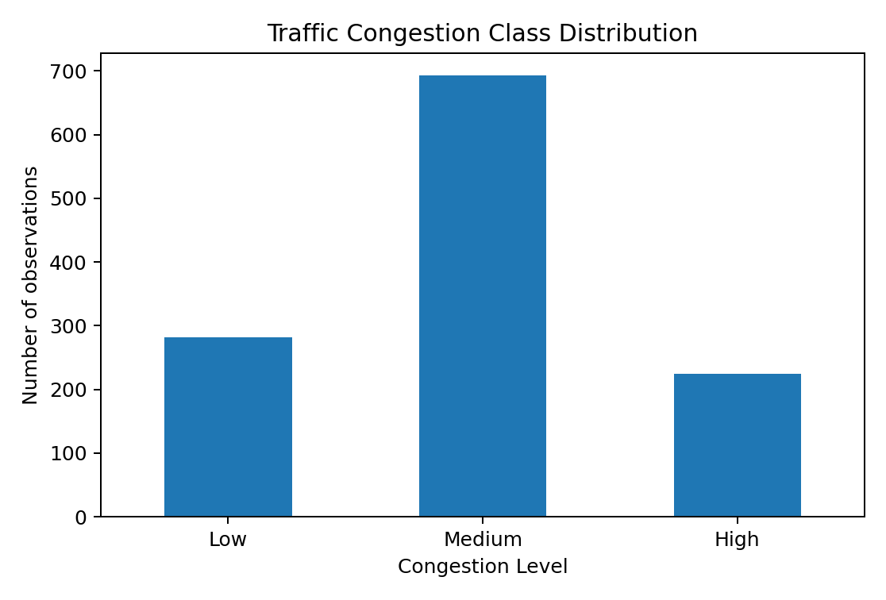
Figure 1. Distribution of the three traffic-congestion classes.
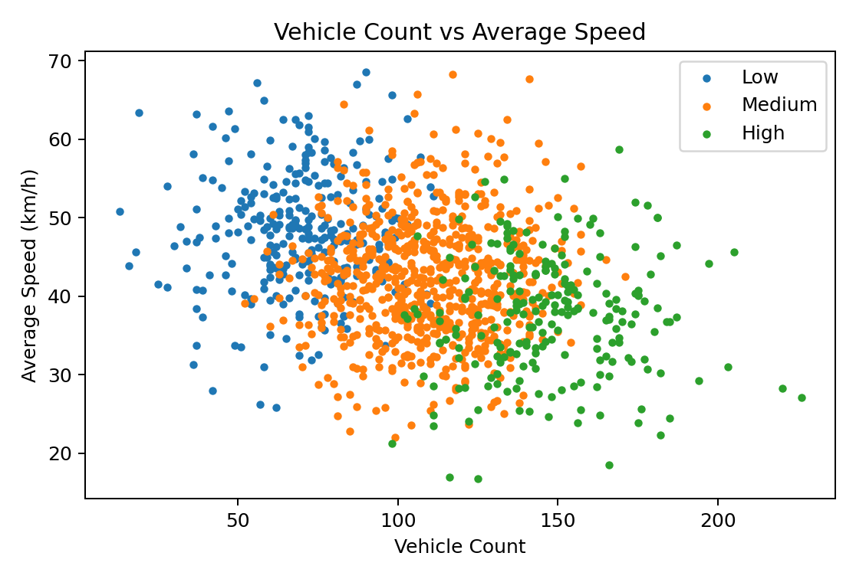
Figure 2. Relationship between vehicle count and average speed.
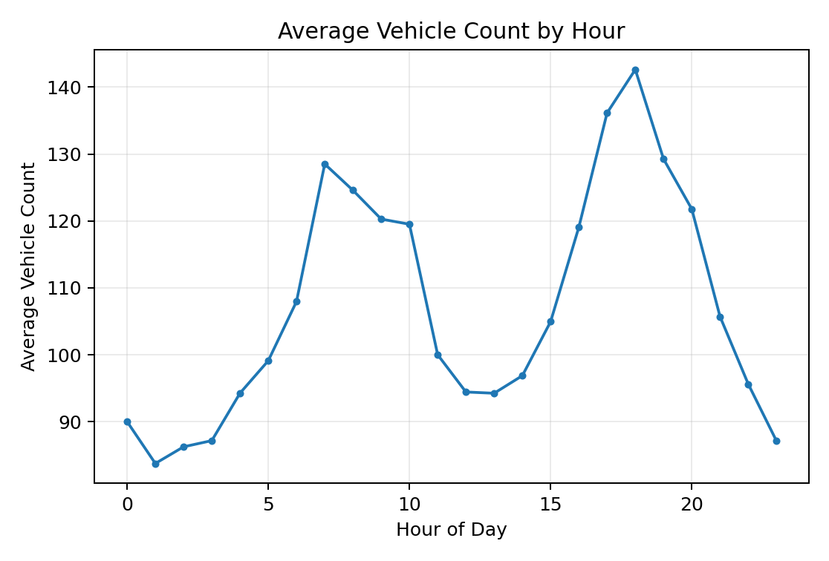
Figure 3. Average vehicle count according to hour of day.
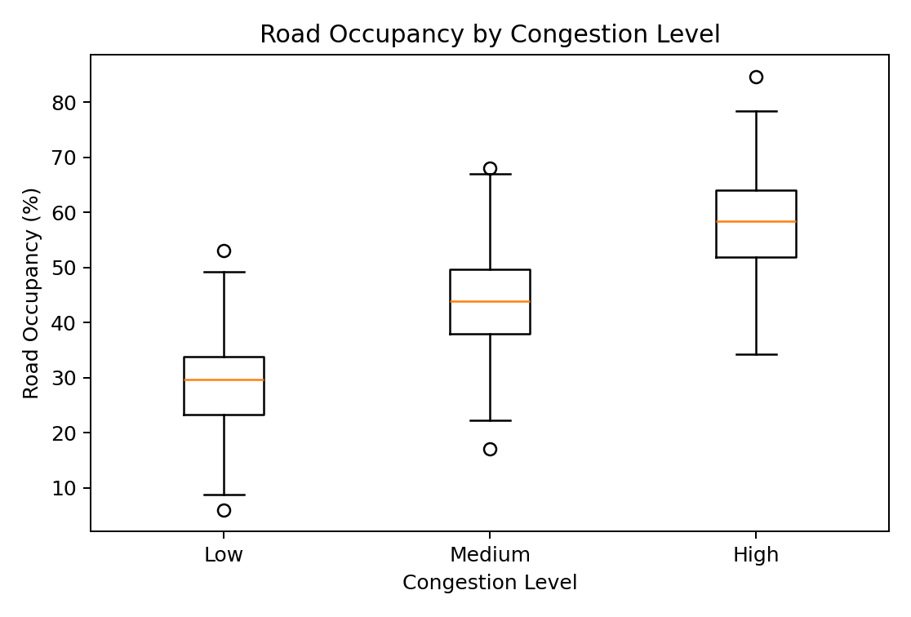
Figure 4. Road occupancy distribution for Low, Medium and High congestion.
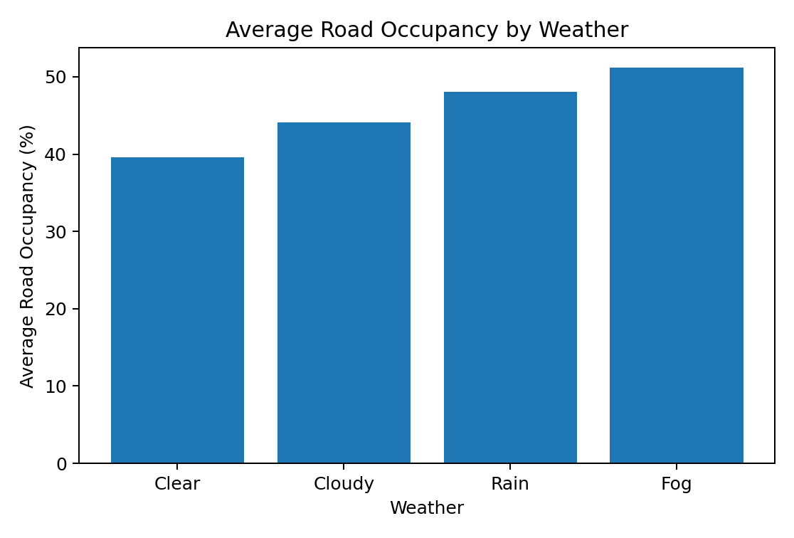
Figure 5. Average road occupancy under different weather conditions.

2.3 Decision Tree Model Development
A Decision Tree classifier was selected because the problem is a multiclass classification task and the resulting decision rules can be interpreted easily. The Gini impurity criterion was used for splitting. The tree depth was limited to five and the minimum number of samples per leaf was set to ten to reduce unnecessary model complexity. The model was trained only on the training subset and evaluated on the held-out test subset.
Table: Decision Tree Model Configuration
Parameter | Selected setting | Reason
Algorithm | DecisionTreeClassifier | Suitable for multiclass classification and interpretable threshold-based rules.
Splitting criterion | Gini impurity | Used to select splits that reduce class impurity.
Maximum depth | 5 | Limits unnecessary tree complexity.
Minimum samples per leaf | 10 | Reduces very small terminal groups and overfitting risk.
Train-test split | 80% / 20%, stratified | Keeps class proportions consistent between training and testing.
Random state | 42 | Makes the experiment reproducible.
For a decision-tree node, the Gini impurity is given by G = 1 − Σpᵢ², where pᵢ is the proportion of observations belonging to class i. The algorithm selects splits that reduce the weighted impurity of the child nodes.
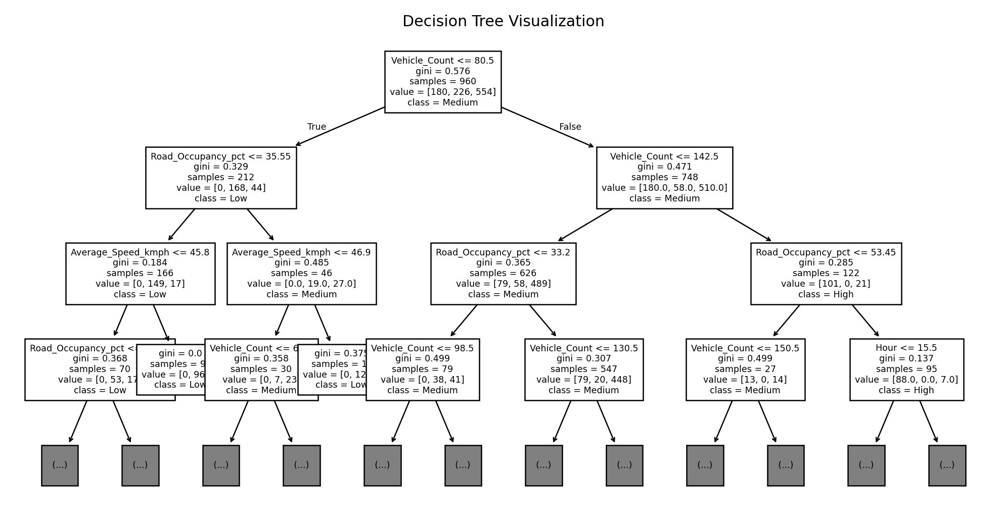
Figure 6. Decision Tree visualization showing the upper levels of the trained classifier.

2.4 Feature Importance Analysis
Feature importance values were obtained from the trained Decision Tree. They provide a relative indication of how strongly each input contributes to the tree's splitting decisions. In this dataset, vehicle count, road occupancy and average speed are the main direct indicators of congestion, while time and categorical context provide supporting information.
Table: Feature Importance from the Decision Tree
Rank | Feature | Importance | Interpretation
1 | Vehicle_Count | 0.7585 | Strongest direct contributor to the learned splits.
2 | Road_Occupancy_pct | 0.1969 | Important indicator of how much road capacity is being used.
3 | Average_Speed_kmph | 0.0393 | Provides additional information about traffic restriction.
4 | Hour | 0.0053 | Provides limited contextual information in this model.
5 | Day_Friday | 0.0000 | No measurable contribution in the fitted tree.
6 | Day_Monday | 0.0000 | No measurable contribution in the fitted tree.
7 | Day_Saturday | 0.0000 | No measurable contribution in the fitted tree.
8 | Day_Sunday | 0.0000 | No measurable contribution in the fitted tree.
· Vehicle_Count: 0.7585
· Road_Occupancy_pct: 0.1969
· Average_Speed_kmph: 0.0393
· Hour: 0.0053
· Day_Friday: 0.0000
· Day_Monday: 0.0000
· Day_Saturday: 0.0000
· Day_Sunday: 0.0000
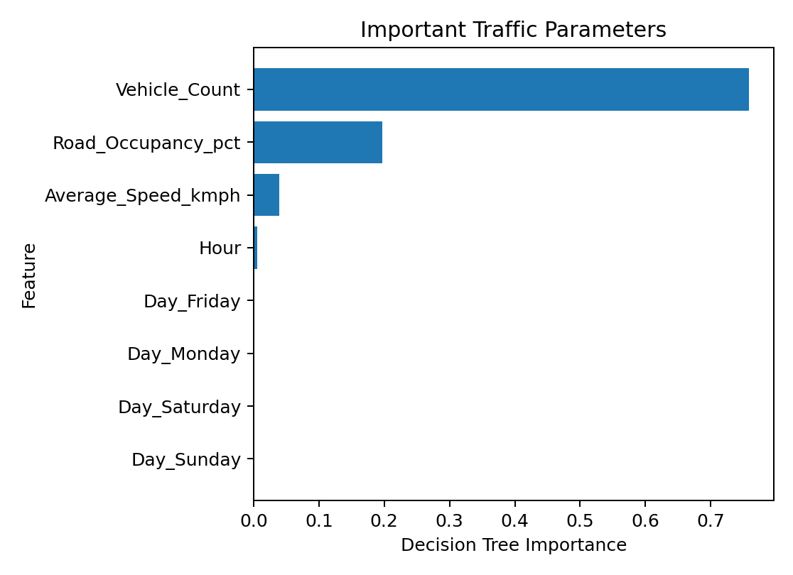
Figure 7. Relative importance of the selected traffic parameters.

2.5 Mathematical Model
Let the input vector be x = [V, S, H, D, W, O], where V is vehicle count, S is average speed, H is hour, D is day, W is weather and O is road occupancy. The classifier produces y ∈ {Low, Medium, High}. The final class is determined by the sequence of threshold decisions learned from the training data.
The overall accuracy is calculated as Accuracy = Correct Predictions / Total Predictions. Precision measures the proportion of predicted class labels that are correct, recall measures the proportion of actual class members that are correctly identified, and the F1-score is the harmonic mean of precision and recall.

3. Solution / Design / Methodology
The proposed system is divided into five stages: traffic-data acquisition, preprocessing, exploratory analysis, Decision Tree modelling, and prediction/evaluation. Historical traffic data are used to train the classifier, while the same feature-processing pipeline can later accept live sensor measurements.
Stage | Main Operation | Output
1. Data acquisition | Collect vehicle count, speed, occupancy, time, day and weather information. | Traffic observation
2. Preprocessing | Clean data and encode categorical variables. | Model-ready features
3. Analysis | Generate summaries, grouped statistics and visualizations. | Traffic patterns
4. Modelling | Train the constrained Decision Tree classifier. | Trained model
5. Prediction & evaluation | Classify new observations and calculate performance metrics. | Congestion result and validation

3.1 System workflow
1. Read the latest traffic observation from the sensing or monitoring system.
2. Check the record for missing or invalid values.
3. Apply the same categorical encoding used during training.
4. Pass the processed feature vector to the Decision Tree.
5. Return Low, Medium or High congestion.
6. Use the result as decision support for routing, signal timing or congestion management.

3.2 Testing with New Traffic Data
A new observation was tested with 205 vehicles, an average speed of 22.5 km/h, 18:00 on Friday, Rain weather and 86% road occupancy. The model predicted High congestion. This observation combines relatively high vehicle demand and occupancy with a reduced speed during an evening period, which is consistent with a heavy traffic condition.
Parameter | New observation
Vehicle count | 205
Average speed | 22.5 km/h
Time | 18:00
Day | Friday
Weather | Rain
Road occupancy | 86%
Predicted congestion | High

4. Use of Modern Tools
The implementation uses commonly available Python tools so that the workflow can be reproduced without specialised traffic-simulation software.
· NumPy: numerical operations and controlled generation of the demonstration data.
· Pandas: data storage, cleaning, grouping and aggregation.
· Matplotlib: traffic-pattern, feature-importance and model-result plots.
· Scikit-learn: train-test splitting, Decision Tree classification and evaluation metrics.
· Python: integration of the complete preprocessing, analysis, modelling and testing workflow.

4.1 Python implementation
import pandas as pd
from sklearn.model_selection import train_test_split
from sklearn.tree import DecisionTreeClassifier
from sklearn.metrics import accuracy_score, precision_score
from sklearn.metrics import recall_score, f1_score, confusion_matrix
df = pd.read_csv("traffic_data.csv")
df = df.drop_duplicates().dropna()
X = pd.get_dummies(
df.drop(columns=["Congestion_Level"]),
columns=["Day", "Weather"]
)
y = df["Congestion_Level"]
X_train, X_test, y_train, y_test = train_test_split(
X, y, test_size=0.20,
random_state=42, stratify=y
)
model = DecisionTreeClassifier(
criterion="gini",
max_depth=5,
min_samples_leaf=10,
random_state=42
)
model.fit(X_train, y_train)
y_pred = model.predict(X_test)
print("Accuracy:", accuracy_score(y_test, y_pred))
print("Precision:", precision_score(
y_test, y_pred, average="weighted"))
print("Recall:", recall_score(
y_test, y_pred, average="weighted"))
print("F1-score:", f1_score(
y_test, y_pred, average="weighted"))
print(confusion_matrix(
y_test, y_pred,
labels=["Low", "Medium", "High"]
))

4.2 Sample output
Metric | Obtained result
Training observations | 960
Testing observations | 240
Accuracy | 80.42%
Weighted precision | 80.44%
Weighted recall | 80.42%
Weighted F1-score | 80.25%
New traffic prediction | High
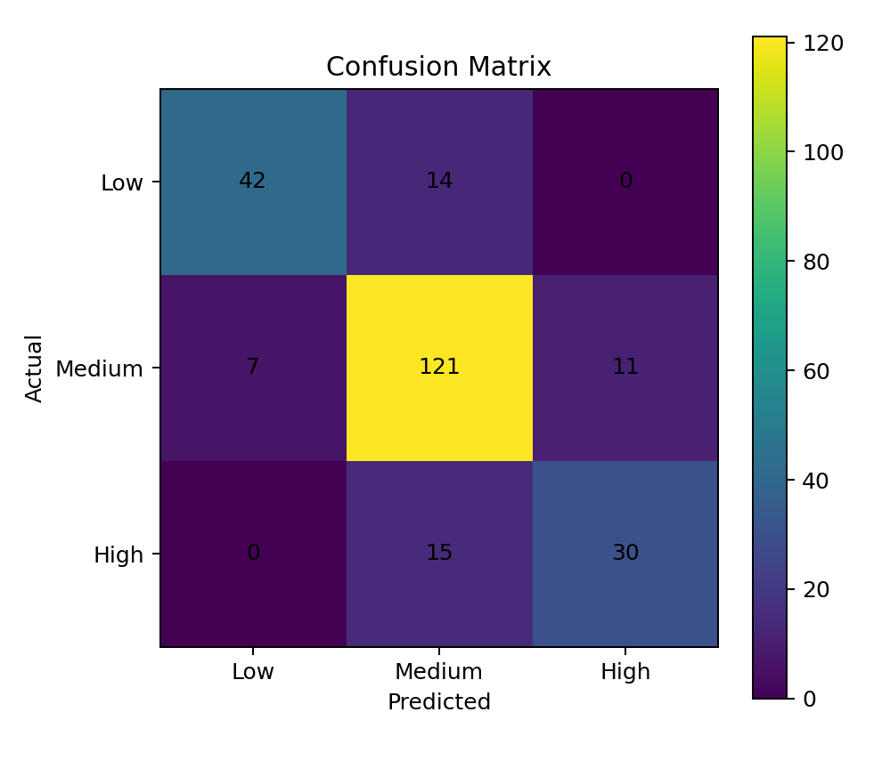
Figure 8. Confusion matrix for the held-out test dataset.

5. Results and Validation

5.1 Model Evaluation
The model was evaluated on the test set that was not used during training. The obtained accuracy, precision, recall and F1-score indicate the overall classification performance. The confusion matrix gives a class-by-class view of correct and incorrect predictions.
Table: Validation Against Assignment Requirements
Requirement | Evidence in the report | Status
Required traffic attributes | Vehicle count, speed, time, day, weather and occupancy are included. | Completed
NumPy and Pandas processing | Used for numerical processing and tabular data handling. | Completed
Statistical analysis and visualization | Five traffic visualizations plus grouped analysis are presented. | Completed
Decision Tree classification | Low, Medium and High congestion are classified using a Decision Tree. | Completed
Feature importance | Feature importance values are calculated and interpreted. | Completed
New traffic-data test | A new observation is tested with a High congestion prediction. | Completed
Model evaluation | Accuracy, precision, recall, F1-score and confusion matrix are reported. | Completed
Real-world application | Route management, signal timing and congestion reduction are discussed. | Completed
Metric | Result | Interpretation
Accuracy | 80.42% | Overall proportion of correctly classified observations.
Precision | 80.44% | Weighted reliability of the predicted congestion classes.
Recall | 80.42% | Weighted ability to identify the actual congestion classes.
F1-score | 80.25% | Balanced summary of precision and recall.
Confusion matrix | Figure 8 | Shows correct and incorrect predictions for each class.

5.2 Class-wise Validation
Class | Precision | Recall | F1-score | Support
Low | 85.71% | 75.00% | 80.00% | 56
Medium | 80.67% | 87.05% | 83.74% | 139
High | 73.17% | 66.67% | 69.77% | 45

5.3 Validation against requirements
· Traffic data containing the required vehicle, speed, time, day, weather and occupancy attributes were prepared.
· NumPy and Pandas were used for numerical processing and tabular data handling.
· Five traffic visualizations were produced before model training.
· A Decision Tree classifier was developed for Low, Medium and High congestion.
· Feature importance was calculated from the trained model.
· The classifier was tested on a new traffic observation.
· Accuracy, precision, recall, F1-score and confusion matrix were reported.
· The final discussion connects the result with route management, signal timing and congestion reduction.

6. Analysis and Engineering Decision

6.1 Important traffic parameters
Vehicle count, road occupancy and average speed are the most directly meaningful variables for congestion classification. A high vehicle count indicates greater demand, while high occupancy indicates that more of the available road capacity is being used. Lower average speed provides an additional indication that traffic is becoming constrained. Using these variables together gives a more useful representation than relying on a single measurement.

6.2 Role of time and weather
Traffic demand changes during the day and commonly increases around morning and evening travel periods. Weather can also influence speed, spacing and road usage. These variables therefore provide useful context, although the direct road-state measurements remain the most important indicators in the model.

6.3 Why a Decision Tree was selected
A Decision Tree was chosen because it is suitable for multiclass classification, can represent nonlinear threshold relationships and does not require numerical feature scaling. More importantly for a traffic-control application, the learned rules can be inspected by an engineer instead of treating the prediction as an unexplained output.

6.4 Limitations
· The dataset used for this demonstration is synthetic, so the reported performance should not be treated as a guaranteed result for a real city.
· Unexpected events such as accidents, road construction, public gatherings and sensor failures are not explicitly modelled.
· A single Decision Tree can be sensitive to changes in training data.
· Weather categories are relatively broad and do not represent every environmental condition.
· A practical deployment would require real traffic data, continuous quality checks and periodic model validation.

7. Broader Considerations
Table: Practical Use of the Prediction Result
Traffic-management area | Possible use of prediction | Expected benefit
Route management | Suggest alternate routes when a road segment is predicted as High congestion. | Can reduce load on heavily congested segments.
Traffic signal timing | Give higher priority or longer green time to approaches experiencing higher congestion. | Can improve traffic movement at busy junctions.
Congestion reduction | Use repeated predictions to identify developing congestion and respond earlier. | Supports proactive rather than purely reactive traffic control.
Intelligent transportation management | Combine predictions from several monitored road segments. | Provides a wider view of current traffic conditions.
· Sustainability and SDG 11: better traffic management can contribute to more efficient and sustainable urban mobility.
· SDG 9: the project demonstrates the use of data and machine learning with transportation infrastructure.
· Environmental impact: reducing unnecessary idling and stop-and-go movement can potentially reduce fuel consumption and emissions, although these benefits would need to be measured in a real deployment.
· Privacy: camera-based systems should extract only the traffic information required for congestion estimation and avoid unnecessary storage of personal information.
· Reliability: model performance should be checked across different road segments, times and weather conditions instead of relying only on one aggregate score.
· Professional responsibility: the prediction should be treated as decision support, with a safe fallback procedure when sensor data are missing or unreliable.

8. Conclusion
The assignment developed a machine-learning workflow for predicting urban traffic congestion using vehicle count, average speed, time, day, weather and road occupancy. The data were prepared using NumPy and Pandas, analysed through statistical summaries and visualizations, and classified using a constrained Decision Tree. Feature importance was used to identify the traffic variables that most influenced the learned model. The classifier was evaluated using accuracy, precision, recall, F1-score and a confusion matrix, and a new traffic observation was successfully classified. The results show how an interpretable machine-learning model can support traffic-management decisions such as route selection, signal timing and congestion reduction. The main limitation is the use of synthetic data, so real-world deployment would require validation with actual traffic records, monitoring for changing conditions and appropriate privacy safeguards.

9. Student Reflection
One of the main difficulties in this assignment was deciding how to convert traffic measurements into a form that a machine-learning model could use without losing their practical meaning. Vehicle count, speed and occupancy describe different parts of the same traffic condition, so looking at them separately was not enough. Using Pandas made it easier to organise the records and compare groups, while the visualizations helped me understand the patterns before building the classifier.
The Decision Tree was useful because its predictions are easier to relate to actual traffic conditions than a completely opaque model. I also found that model evaluation should not stop at accuracy. The confusion matrix and the precision, recall and F1-score values give more information about how the different congestion classes are being identified.
The biggest limitation of the work is the use of a synthetic dataset. The model may perform differently when exposed to real traffic data containing accidents, road works, special events, sensor errors and seasonal changes. If I continued the project, I would test the model with real traffic records and compare the Decision Tree with ensemble methods. I would also connect the prediction output to a simple dashboard so that a traffic operator could see the current congestion state and the main factors behind it. Overall, the assignment helped me understand how data preprocessing, visualization, classification and evaluation fit together in a practical machine-learning application.

10. References
· Pedregosa, F. et al., Scikit-learn: Machine Learning in Python, Journal of Machine Learning Research.
· McKinney, W., Python for Data Analysis, O'Reilly Media.
· Harris, C. R. et al., Array programming with NumPy, Nature.
· Matplotlib documentation, Python plotting and visualization library.
· Course lecture notes and learning material, ITA0614 – Machine Learning.
· United Nations Sustainable Development Goals documentation, SDG 9 and SDG 11.
· Any AI-assisted drafting or coding support used for this assignment should be acknowledged according to the course requirements.
Table: Assignment Task-wise Assessment Rubric Summary
Assessment criterion | Max marks | Expected evidence
Data Collection & Preprocessing using NumPy and Pandas (Task 1) | 15 | Traffic data is loaded, cleaned and preprocessed; missing values and categorical data are handled.
Statistical Analysis & Visualization (Task 2) | 15 | Statistical summaries and meaningful visualizations reveal relationships between congestion and input parameters.
Decision Tree Model Development (Task 3) | 20 | Decision Tree is correctly designed, trained and configured for Low/Medium/High congestion.
Feature Importance Analysis (Task 4) | 10 | Important traffic parameters are identified, ranked and interpreted.
Testing with New Real-Time Data (Task 5) | 10 | The trained model is tested with unseen traffic parameters and produces a congestion prediction.
Model Evaluation: Accuracy, Precision, Recall, F1-score & Confusion Matrix (Task 6) | 15 | All requested evaluation measures and the confusion matrix are presented and interpreted.
Discussion: Real-World Impact & SDG Relevance (Task 7) | 15 | The prediction is linked to route management, signal timing, congestion reduction and SDG relevance.

F. Common Assessment Rubric (as per course format) — Cross-Reference
Assessment Criterion | Marks | Addressed In
Problem Understanding & Requirements Formulation | 10 | Section E.1
Application of Machine Learning, NumPy & Pandas Concepts | 20 | Section E.2
Solution Design: Decision Tree, Feature Analysis & Prediction | 20 | Section E.3
Use of Appropriate Modern Tools | 10 | Section E.4
Results & Model Validation | 15 | Section E.5
Analysis & Engineering Justification | 15 | Section E.6
Broader Considerations: SDG, Ethics & Professional Responsibility | 5 | Section E.7
Technical Documentation & Reflection | 5 | Section E.9 + overall report
TOTAL | 100

G. CO–PO–Assessment Mapping
The PO column is left for completion according to the programme-level mapping used by the department. The CO and Bloom's-level associations below follow the machine-learning assignment question.
Assessment Component | CO | PO(s) | Bloom's Level | Marks
Problem formulation | CO6, CO8 | PO(s) — | L3/L4 | 10
Application of knowledge | CO6–CO8 | PO(s) _ | L3/L4 | 20
Solution / Design / Implementation | CO6, CO8 | PO(s) — | L4/L5 | 20
Modern tool usage | CO7, CO8 | PO(s) — | L3/L4 | 10
Validation | CO6, CO8 | PO(s) — | L4/L5 | 15
Analysis & justification | CO6–CO8 | PO(s) | L4 | 15
Broader considerations | CO8 | PO(s) | L4 | 5
Documentation & reflection | CO8 | PO(s) | L3/L4 | 5

